Media Release
4ZZZ ‘Voiceability’ Series released
What do you know about the lives and interests of people with cognitive difficulties? Likely not much, because representation of people with intellectual disabilites (ID) in the mainstream media is practically non-existent. This reflects a wider lack of social inclusion of people with ID.
Understanding this problem, social activists from the Community Living Association and WWILD-Sexual Violence Project got together with Community Radio 4 Triple Zed in Brisbane to run a 14 week radio group, the Ability Radio Project.
Our co-produced radio series, Voiceability, is the result. You can listen to the result in our 10 part Segment series (8 minutes each) downloadable from our Soundcloud account at:
https://soundcloud.com/abilityradioproject/
We would like to thank the Community Broadcasting Associatin of Australia - Segments Series - for allowing us to tell our stories to a national audience.
For more information about the project and resources for support workers who might like torun their own radio project, check out our website at http://abilityradioproject.wordpress.com
Series producers:
Kim Stewart & Ben Stimpson
Media: contact Kim 0413 397839

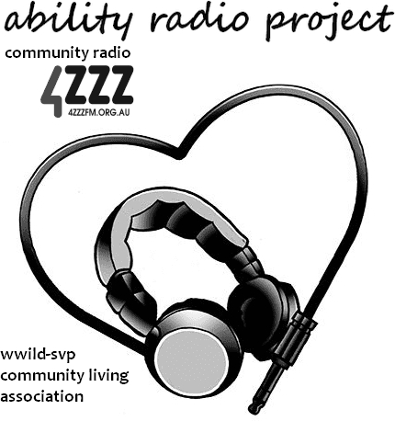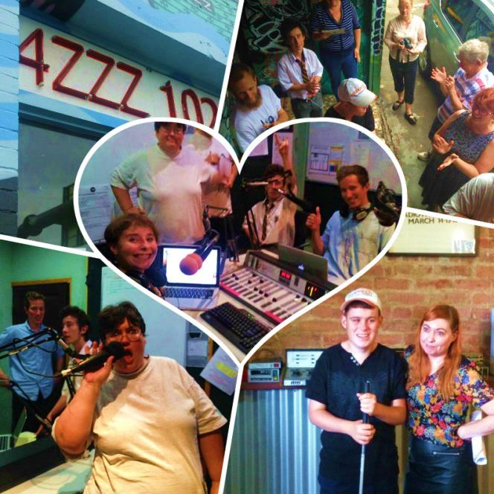

Voiceability – Synopsis
Episode and Synopsis | Voices
1. Getting around  Moving about the world as a person with a disability is fraught with difficulties. In this first episode we talk about some of our lived experiences of people with a physical disability. Music: PKN, Atmosphere. | Alicia  Jayden  James  Ben & Kim
2. Work  A form of socially valued activity that many people with ID miss out on, work is also a valuable place to meet people and make friends. Music: PKN, They Might Be Giants. | James  Felice  Jesse  Ben & Kim
3. Education  Our group talks about the good and bad of their educational experiences. Music: PKN, Alice Cooper.  *Trigger warning* This episode has content that may upset people who have experienced trauma | James  Felice  Michael  Jayden  Ben & Kim
4. Family  Love them or hate them, we can't choose them. We talk about family. Music: PKN, Jack Johnson. | Jesse  James  Jayden  Ben & Kim
5. Independent Living  One of the challenges for people with ID is achieving independence. Music: PKN, Tralala Blip. | Felice  James  Jesse  Jayden  Ben & Kim
6. Animals  Some of our best and most memorable friends are our pets and animals we admire. Music: PKN, Gorillaz feat. Lou Reed. | Glenn  Leona  Bernadette (ABC)  Alex (4EB)  Ben & Kim
7. Mental health and disability  People with ID often suffer from depression and other mental health problems. Our group recognise the importance of seeking help. Music: PKN, Vitamin String Quartet.  *Trigger warning* This episode has content that may upset people who have experienced trauma | Jayden  James  Jesse  Ben & Kim
8. Community  What does it mean to be part of a community? What is the experience of inclusion for people with an ID? What is real social inclusion? Music: PKN, The Tragically Hip. | Felice  James  Morrie  Ben & Kim
9. Seeking support  No one is an island. Living with an intellectual disability often means our island is populated with support workers, carers or guardians. Music: PKN, The Kinks. | Ben & Kim
10. Being and disability  Is it only a word? How does it define, or not? Music: PKN, David Bowie. | James  Felice  Jayden  Ben & Kim

